Lore Tree | Arcanist
  Lore | AP | Choice One | Choice Two
  100 |  | +1 to Any Skill | +2 Max Vita
  200 | +1 | Discard a Ritual to recover all  Power Points. | Discard a Ritual to force a foe to lose  their next turn.
  350 | +1 | Lose 5 Lore to gain 1 Power Point,  once per chapter. | Re-roll a missed skill check when reciting a Ritual, once per round.
  350 Lore: As a ghost, gain +5 Defense and +1 Max Ghost Points.
  500 | +1 | NUMEROLOGIST: Add 1d4 to any die roll, once per chapter.  SEEKER: +1 Damage with melee weapons if your target has an adjacent ally. | NUMEROLOGIST: Once per story,  a Companion may block one attack  without sacrificing their life.  SEEKER: +5 Might for each round you have consecutively attacked the same target, maximum +20.
  650 | +1 | +1 Max Power Point | +1 to Any Skill
  800 | +1 | +5 Might | +5 Defense
  800 Lore: As a ghost, gain +5 Defense and +1 Max Ghost Points.
  950 | +1 | Pass OCCULT 9 to cause an Occultist‘s attack to be re-directed to a foe of your choice, once per encounter. | Pass OCCULT 9 to cause an Occultist to lose their next turn, once per encounter.
  1100 | +2 | +1 to Any Skill | +2 Max Vita
  1250 |  | +1 Max Power Point | +1 Stride
  1250 Lore: As a ghost, gain +5 Defense and +1 Max Ghost Points. You may also retrain abilities.
  1400 | +1 | NUMEROLOGIST: Recover 1 Power Point when you Defend during a skirmish and one extra Power Point when resting.  SEEKER: The Light Aura heals 1 Vita  per round and the Dark Aura deals 1 Damage to foes per round. | NUMEROLOGIST: You may re-roll any one attack roll, once per combat.  SEEKER: The Light Aura acts as a light source and the Dark Aura causes REDUCTION 1 to foes.
  1550 | +1 | ABSORPTION 1 from Occultist attacks. | When a Spirit creature is slain, gain the ETHEREAL status until the end of the chapter.
  1700 | +2 | NUMEROLOGIST: You may change the result of any one die roll to the number of your choice, once per story.  SEEKER: Her auras increase from AURA 1 to AURA 2. | Add +1 to your DMG Bonus.
  The Arcanist seeks hidden knowledge and mastery of the secrets of the universe. She is a student of the ancient systems of numerology and chakric mysticism. As a collector of lost knowledge, she has found an old parchment torn from the pages of a much larger book known as the Necronomicon. The Arcanist seeks to find the remainder of this obscure text and explore the other dimensions of which it speaks.
  C H O O S E A C H A R A C T E R F O C U S
  ❐ Numerologist  You have studied and learned the lore of numbers and their mystical meanings.  Once per chapter, the Numerologist can spend a Power Point to re-roll any of her own die rolls.  Once per story, she may roll two dice instead of one for any roll she wishes in the game and take her choice of the higher or lower of the two values. | ❐ Seeker  The Seeker has two auras and can use them as long as she has at least one unspent Power Point. These auras are represented by a double-sided token with a light and dark side.  Once per combat (both encounters and skirmishes), the Seeker may activate one of her auras. Each is AURA 1 and lasts  for 4 rounds.  The Light aura is a circle of protection giving her ABSORPTION 1 and allies in the aura +5 Defense. This does not stack with other absorption bonuses.  The Dark aura causes 1 Damage to all foes that move into the aura on their turn.
**** | *

sTARTING aBILITIES | Location Extras
  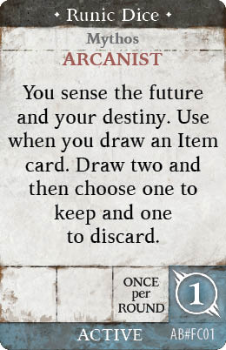 | 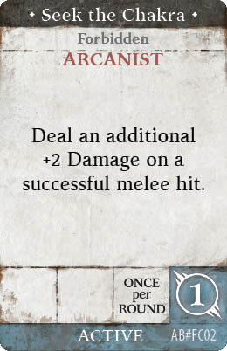
  Starting Equipment
  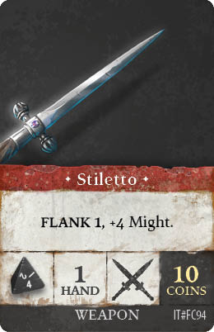 | 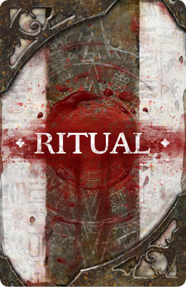
    Alchemist
    35  coin | Hierophant Amulet (Item): Discard any consumable Item to recover 2 Vita and allow an ally to recover 1 Vita [Chest or Neck / Enhancement].
    45  coin | Robes of the Enchanter (Item):  Reflect a ranged attack back at the foe once per story [Chest or Neck / Enhancement].
    Apothecary
    50  coin | Harpy Feather (Item): You cannot be moved against your will [Enhancement].
    Gypsy Encampment
    75  coin | Changing your Fate: Purchase one Tarot card of your choice and remove it from the game (one time only).
    50  coin | Rabbit’s Foot (Item): EXHAUST for the story to gain the Lucky status for one map [Enhancement].
    60  coin | Bone Dice (Item): Ancient dice made from the remains of an unfortunate corpse. EXHAUST to gain +1 to a die roll [Enchantment].
    Inn
    60  coin | Gather Secrets: Learn the hidden secrets about your enemies. Gain +1 Damage against Afflictions for this story.
    Market
    60  coin | Reinforced Bodice (Item):  +4 Defense, +2 to the number of  Items you can carry [Chest / Enhancement].
    50  coin | Scarlet Cloak (Item): +1 TRICKERY [Chest or Neck / Enhancement].
    Stables
    35  coin | Familiar (Companion):  A cat Companion, which gives you  +1 Power Point and +1 AWARENESS.
    Standing Stones
    50  coin | One with the Universe: Commune with the universe and remove all your negative statuses.
    Tinker
    50  coins | Dowsing Rod (Item): Find water to drink in any Off-Road space, recovering 1 Vita [Enhancement].
    50  coin | Throwing Knives (Item): 1d4+1, RANGE 3, Ammo 3  [1 Hand / Melee Weaponry].
** | ****

